A Project Report on

Smart Agricultural Crop Disease Detection
Submitted in partial fulfillment for award of

Bachelor of Technology Degree
in

Computer Science and Engineering

By
K. Raviteja (Y22ACS479) A. Suresh (Y22ACS5414)
J. Meena (Y22ACS466) G. Ramteja (L23ACS599)


Under the guidance of
N.Srikanth,M.Tech(Ph.D)
Asst.Professor,CSE
Department of Computer Science and Engineering

Bapatla Engineering College
(Autonomous)
(Affiliated to Acharya Nagarjuna University)
BAPATLA – 522102, Andhra Pradesh
2025-2026

Department of Computer Science
and Engineering



CERTIFICATE

This is to certify that the project report entitled Smart Agricultural Crop Disease Detection that is being submitted by K.Raviteja (Y22ACS479) A.Suresh (Y22ACA414) J.Meena (Y22ACS466) G.Ramteja (L23ACS599) in partial fulfillment for the award of the Degree of Bachelor of Technology in Computer Science & Engineering to the Acharya Nagarjuna University is a record of bonafide work carried out by them under our guidance and supervision.

Date:

Signature of the Guide Signature of the HOD
N.Srikanth Dr. M. Rajesh Babu
Asst.Professor, CSE Assoc. Prof. & Head

DECLARATION
We declare that this project work is composed by ourselves, that the work contained herein is our own except where explicitly stated otherwise in the text, and that this work has not been submitted for any other degree or professional qualification except as specified.

K.Raviteja (Y22ACS479)
A.Suresh (Y22ACS414)
J.Meena (Y22ACS466)
G.Ramteja (L23ACS599)

AKNOWLEDGEMENT

We sincerely thank the following distinguished personalities who have offered their valuable advice and support for the successful completion of this work.
We are deeply indebted to our most respected guide, N. Srikanth, Assistant Professor,
M.Tech (Ph.D), Department of Computer Science and Engineering, for his/her valuable guidance, constant encouragement, constructive suggestions, and inspiring support throughout the course of this project.
We extend our sincere thanks to Dr. M. Rajesh Babu, Associate Professor & Head of the Department, Department of Computer Science and Engineering, for his cooperation and for providing the necessary facilities and resources to carry out this work successfully.
We would also like to express our heartfelt gratitude to our beloved Principal, Dr. B. Srinivasarao, for providing the required infrastructure, online resources, and institutional support to complete this project.
We express our sincere thanks to our Project Coordinators, Dr. C. Prakasa Rao, Professor, Department of CSE, and Dr. R. Venkata Lakshmi, Assistant Professor, Department of CSE, for their valuable suggestions and guidance in preparing and presenting this document.
We are always thankful to our parents and family members for their continuous support, encouragement, and motivation. Without their support, we would not have been able to complete this project work successfully.
Finally, we extend our sincere gratitude to all the teaching faculty and non-teaching staff of the Department of Computer Science and Engineering who helped us directly or indirectly with their cooperation and encouragement.

K.Raviteja (Y22ACS479)
A.Suresh (Y22ACS414)
J.Meena (Y22ACS466)
G.Ramteja (L23ACS599)

ABSTRACT
This project presents a web-based Smart Agricultural Crop Disease Detection and Recommendation System designed to identify diseases in major crops such as rice, cotton, maize, and chilli using leaf images. Agriculture plays a vital role in the economy, and early detection of crop diseases is essential to prevent yield loss and ensure healthy production. Traditional methods of disease identification rely heavily on manual inspection and expert consultation, which can be time-consuming, costly, and sometimes inaccurate.
To overcome these challenges, this system utilizes a deep learning approach based on the InceptionV3 convolutional neural network architecture, which is widely known for its high performance in image classification tasks. A comprehensive dataset consisting of both healthy and diseased leaf images was collected and used to train the model. Transfer learning techniques were applied to leverage pre-trained knowledge, enabling the model to efficiently extract complex features from images and accurately classify different types of crop diseases.
The system is implemented as a user-friendly web application using Flask, where users can upload images of plant leaves. The trained model processes the input image, performs preprocessing and feature extraction, and predicts the type of disease present in the crop. In addition to disease identification, the system also provides appropriate product recommendations such as fertilizers, pesticides, or treatment solutions based on the predicted disease, helping farmers take timely and effective action.
Overall, this project aims to provide an efficient, accurate, and accessible solution for crop disease detection, reducing dependency on manual methods and supporting farmers in improving agricultural productivity and crop health.

Table Of Contents:
ABSTRACT……………………................................................................................................v
1. INTRODUCTION..................................................................................................................1
1.1 Motivation ........................................................................................................................1
1.2 Problem Statement .......................................................................................................... .2
1.3 Objective of Project ...........................................................................................................3

2. LITERATURE SURVEY .......................................................................................................5
2.1 Existing System ................................................................................................................7
2.2 Disadvantages of Existing System.....................................................................................8
2.3 Proposed System................................................................................................................9
2.4 Advantages of Proposed System......................................................................................10

3. ANALYSIS ..........................................................................................................................12
3.1 Software Requirements....................................................................................................12
3.2 Hardware Requirements .................................................................................................15

4. DESIGN ................................................................................................................................18
4.1 Introduction ....................................................................................................................18
4.2 System Architecture …………........................................................................................19
4.3 UML Diagrams ...............................................................................................................21
4.3.1 Use Case Diagram ..................................................................................................21
4.3.2 Activity Diagram……...…...............................................................................…..22
4.4 Dataflow ……….............................................................................................................25

5. IMPLEMENTATION & RESULTS ....................................................................................26
5.1 Implementation of Models………………………………………………………….…...26
5.2 Implementation of Algorithms .........................................................................................28
5.3 Home Screen ....................................................................................................................29
5.4 Prediction Screens ............................................................................................................30
5.4.1 Cotton Leaf Prediction screen………………………,…………………....….…….30
5.4.2 Chilli Leaf Prediction screen………………………………………..…………...…31
5.4.3 Maize Leaf Prediction screen……………………….......................................….…31
5.4.4 Rice Leaf Prediction screen…………..………………………………..…….….…32
5.5 Output Screens .................................................................................................................33
5.5.1 Rice Leaf Disease output…….…………………..………………….………….33
5.5.2 Maize Leaf Disease output ……………………..………………….…….......…33
5.5.3 Chilli Leaf Disease output ……………………………...…………………..….34
5.5.4 Cotton Leaf Disease output …………………..…………..……………..…...…34
5.6 Result Analysis……........................................................................................................35

6. TESTING & VALIDATION….............................................................................................37
6.1 Testing Tools and Environment......................................................................................37

7. CONCLUSION & FUTURE ENHANCEMENT..................................................................39
7.1 Conclusion…………………………………………...………………………....………39
7.2 Future Enhancement……………………...…..………………….…………...…….….40
8. BIBLIOGRAPHY…………………………………………………………...……..............42

List of Figures
Figure 4.2 Architecture Diagram………………………………………………………..…….19
Figure 4.3.1 Use case Diagram………………………………………………………………..21
Figure 4.3.2 Activity Diagram……………………………………………………..…….……22
Figure 4.4 Dataflow Diagram………………………………………………………...………25
Figure 5.3 Home Screen……………………………………………...…………..………..….29
Figure 5.4.1 Cotton Leaf Prediction Page…………………………………...…………..……30
Figure 5.4.2 Chilli Leaf Prediction Page………………………………………….……..……31
Figure 5.4.3 Maize Leaf Prediction Page…………………………………………...……..….31
Figure 5.4.4 Rice Leaf Prediction Page…………………………………………........………32
Figure 5.5.1 Rice Leaf Disease Output………………………………………………….……33
Figure 5.5.2 Maize Leaf Disease Output…………………………………………………..…33
Figure 5.5.3 Chilli Leaf Disease Output…………………………………………..……….…34
Figure 5.5.4 Cotton Leaf Disease Output………………………………………………….…34

List of Tables:
Table 2.1 Literature survey of plant diseases…………………………………..………..…..…5
Table 3.1 Software requirements of project………………………………………....……..…14

1 INTRODUCTION
Agriculture plays a crucial role in ensuring food security and economic development, but crop productivity is often affected by various plant diseases that reduce yield and quality. Early detection and proper treatment of plant diseases are important to minimize crop loss and improve farming efficiency. Traditionally, farmers rely on manual inspection to identify plant diseases, which can be time-consuming and may require expert knowledge. With the advancement of Artificial Intelligence and Deep Learning, automated plant disease detection systems have become an effective solution for accurate and fast diagnosis.
This project presents a web-based Plant Disease Detection and Recommendation System that identifies diseases in crops such as rice, cotton, maize, and chilli using leaf images. The system uses a deep learning model based on the InceptionV3 architecture, which is well known for its high performance in image classification tasks. By applying transfer learning techniques, the model can effectively learn complex features from leaf images and classify them into specific disease categories. A user-friendly web application allows users to upload leaf images, and the trained model predicts the disease present in the plant. Based on the detected disease, the system also provides suitable agricultural product recommendations such as fertilizers, pesticides, or treatment solutions to help farmers control and prevent further spread of the disease, thereby supporting better crop management and improved agricultural productivity.
1.1 MOTIVATION OF THE PROJECT:
Agriculture is one of the most important sectors that supports food production and the livelihood of millions of farmers across the world. However, plant diseases continue to be a major challenge, causing significant crop losses and negatively impacting agricultural productivity. Many farmers struggle to identify diseases at an early stage due to limited knowledge, lack of proper training, and restricted access to agricultural experts, especially in rural areas. As a result, diseases often spread rapidly before proper action can be taken, leading to reduced yield and financial losses.
Traditional methods of disease detection rely on manual inspection of crops, which is not only time-consuming but also prone to human error. In many cases, farmers may misidentify diseases or apply incorrect treatments, further worsening the condition of the crops. Additionally, consulting agricultural experts may not always be feasible due to cost, availability, and time constraints. These challenges highlight the need for a simple, fast, and accurate solution that can assist farmers in identifying plant diseases effectively.
With the advancement of Artificial Intelligence, Deep Learning, and Image Processing technologies, it has become possible to develop automated systems that can analyze plant leaf images and detect diseases with high accuracy. This project is motivated by the idea of leveraging these modern technologies to build an intelligent system that simplifies disease detection and makes it accessible to farmers.
The proposed system provides a user-friendly web application where farmers can easily upload images of plant leaves. The system processes the image using a trained deep learning model and instantly predicts the type of disease present. In addition to detection, it also offers suitable treatment recommendations such as fertilizers, pesticides, or preventive measures, helping farmers take timely and effective action.
The primary motivation behind this project is to bridge the gap between advanced technology and practical farming by providing an efficient, accessible, and reliable tool. This system aims to reduce crop losses, improve decision-making, save time and cost, and ultimately enhance agricultural productivity and sustainability.

1.2 PROBLEM STATEMENT
Plant diseases are one of the major factors affecting agricultural productivity and crop quality, leading to significant economic losses for farmers. These diseases can spread rapidly if not identified and treated at an early stage, resulting in reduced yield, poor crop health, and increased farming costs. Early and accurate detection of plant diseases is therefore essential to ensure healthy crop growth and sustainable agriculture.
However, the existing methods of plant disease detection primarily depend on manual observation by farmers or consultation with agricultural experts. This process is not only time-consuming but also highly dependent on the experience and knowledge of the individual. In many rural areas, farmers often lack access to skilled experts or proper guidance, making it difficult to accurately identify diseases. As a result, farmers may misinterpret symptoms or fail to detect diseases in their early stages.
Another major issue is the improper use of pesticides and fertilizers due to incorrect diagnosis. Farmers may apply unsuitable treatments, which not only fail to cure the disease but can also harm the crop, soil quality, and the environment. Delayed detection and incorrect treatment further increase the risk of disease spread, leading to severe crop damage and financial loss.
Moreover, traditional methods do not provide instant results, and farmers may have to wait for expert advice, which is not always practical during critical stages of crop growth. This highlights the need for a faster, more accurate, and easily accessible solution for plant disease detection.
To address these challenges, there is a need for an automated and intelligent system that can detect plant diseases using modern technologies such as deep learning and image processing. The system should be capable of analyzing leaf images, identifying diseases accurately, and providing appropriate treatment recommendations.
The objective of this project is to develop a web-based Smart Agricultural Crop Disease Detection and Recommendation System that enables farmers to upload leaf images and receive instant disease predictions along with suitable solutions. This system aims to reduce dependency on manual methods, minimize errors, save time, and support farmers in making better decisions to improve crop health and productivity.

1.3 OBJECTIVES OF THE PROJECT
The primary objective of this project is to develop an accurate, efficient, and user-friendly web-based system for detecting plant diseases in major crops such as rice, cotton, maize, and chilli using leaf images. The system is designed to assist farmers in identifying plant diseases at an early stage, thereby reducing crop damage and improving agricultural productivity.
One of the key objectives of this project is to utilize advanced deep learning techniques, specifically the InceptionV3 convolutional neural network architecture, to automatically classify plant diseases based on visual features extracted from leaf images. By applying transfer learning, the system can effectively learn from pre-trained models and achieve high accuracy even with limited datasets.
Another important objective is to provide real-time disease diagnosis through a simple web interface, where users can upload images and instantly receive predictions. This eliminates the need for manual inspection and reduces dependency on agricultural experts, making the system more accessible to farmers, especially in rural areas.
The project also aims to integrate a recommendation system that suggests suitable agricultural products such as fertilizers, pesticides, and treatment solutions based on the detected disease. This helps farmers take appropriate and timely action to control the disease and prevent further spread.
In addition, the system is designed to minimize human error, reduce time and cost involved in disease identification, and improve decision-making in farming practices. By combining artificial intelligence with practical agricultural applications, the project aims to promote smart farming and sustainable agriculture.
Overall, the objectives of this project focus on improving accuracy, efficiency, accessibility, and usability of plant disease detection systems, ultimately helping farmers increase crop yield, reduce losses, and enhance overall productivity.

2 LITERATURE SURVEY
The study of plant disease detection has evolved over the years with the advancement of technology. Earlier methods mainly relied on traditional laboratory-based techniques. In 2018, research by Smith et al. used serological testing, which provided high accuracy but required laboratory setup, making it costly and less accessible for farmers.
In 2019, Kumar et al. introduced image processing techniques such as thresholding and segmentation. These methods were faster compared to manual approaches but were highly dependent on image quality and lighting conditions, which affected accuracy.
By 2020, machine learning methods like Support Vector Machine (SVM) and K-Nearest Neighbors (KNN) were used by Rao et al. These approaches automated the classification process but required manual feature extraction, which increased complexity and reduced efficiency.
In 2021, Patel et al. implemented deep learning techniques using Convolutional Neural Networks (CNN). This approach significantly improved accuracy by automatically learning features from images, reducing the need for manual intervention.
From the survey, it is clear that deep learning methods provide better performance compared to traditional and machine learning techniques. Therefore, this project uses an advanced deep learning model (InceptionV3) to achieve higher accuracy and efficiency in plant disease detection.
Table 2.1 Literature survey of plant diseases
S. No | Author and Year of Publication | Types of leaves | Algorithm Used for Classification | Reported Accuracy | Types of disease detected
1. | Biswas et al. 2014 [4] | Leafs of Potato | Fuzzy C-means Clustering Neural Network | 93% | Potato Leaf Blight
2. | Joshi & Jadhav 2016 [5] | Disease affected Rice leaf | Minimum Distance classifier | 89.23% | Rice blast & Rice Sheath Rot
3. | Pawar et al., 2016 [7] | Leaves of cucumber plant | Artificial Neural Network | 80.45% | Downy Mildew & Powdery mildew
4. | Kaur & Laxmi 2016 [8] | General Leaves | SVM with optimization technique | 96.77% to 98.42% | Bacterial Blight, Anthracnose
5. | Sun et al., 2017 [9] | Tulip Tree & Chinese Buckeye | Deep Learning | 91.78% | Classification of plants
6. | Mukherjee et al., 2017 [11] | Tulsi Leaves | Multi-Layer Back Propagation Perceptron | 80% | Health of tulsi leaves
7. | Jothiaruna, et al., 2019 [13] | General Plant disease images | Region Growing and Color feature Extraction | 87% | Disease affected portion segmentation
8. | Naikwadi & Amoda 2012 [14] | Diseases affecting pomegranate | Artificial Neural Network | 91% | Alternaria, BBD and Anthracnose

2.1 EXISTING SYSTEM:
The existing system for plant disease detection primarily depends on conventional methods such as manual observation by farmers or consultation with agricultural experts. In this approach, farmers visually inspect plant leaves to identify symptoms of diseases based on their personal experience or knowledge. However, this method is often unreliable, as many diseases exhibit similar visual characteristics, making accurate identification difficult. Additionally, farmers in rural areas may not always have access to trained experts, which further limits the effectiveness of this approach.
To achieve more precise diagnosis, laboratory-based testing methods such as serological or biochemical analysis are sometimes used. Although these techniques provide higher accuracy, they require specialized equipment, controlled environments, and skilled professionals. This makes them expensive, time-consuming, and impractical for regular use by farmers, especially in remote or underdeveloped regions.
With the advancement of technology, some systems have introduced image processing and basic machine learning techniques for disease detection. These systems typically use methods like image segmentation, feature extraction, and classification algorithms such as Support Vector Machines (SVM) or K-Nearest Neighbors (KNN). While these approaches improved automation to some extent, they still have several limitations. They often require manual feature extraction, are sensitive to variations in lighting and image quality, and may not generalize well across different crops or disease conditions.
Moreover, most of the existing systems focus only on disease identification and do not provide additional support such as treatment suggestions or product recommendations. They also lack user-friendly interfaces, making them difficult for farmers to use effectively.
Overall, the current systems are limited by issues such as lower accuracy, lack of real-time results, dependency on human expertise, and limited accessibility. These challenges highlight the need for an advanced, automated, and intelligent solution that can provide accurate, fast, and user-friendly plant disease detection along with actionable recommendations for farmers.

2.2 DISADVANTAGES OF EXISTING SYSTEMS:
1. Dependency on Large and High-Quality Datasets:
The performance of deep learning models highly depends on the availability of large, well-labeled, and high-quality datasets. Collecting such datasets for different crops and disease conditions is time-consuming and challenging. Poor-quality or imbalanced data can lead to inaccurate predictions and reduced model reliability.
2. Sensitivity to Image Quality and Environmental Conditions:
The system’s accuracy may be affected by variations in lighting, background noise, camera quality, and image resolution. Images captured in real-world farm conditions may not always meet the required standards, which can impact prediction performance.
3. Technical and Integration Complexity:
The system involves multiple components such as deep learning models, web application frameworks, and recommendation modules. Integrating all these components increases system complexity, making development, testing, and maintenance more challenging.
4. Limited Generalization Across All Crops and Diseases:
The current system is trained on specific crops like rice, cotton, maize, and chilli. It may not perform accurately for other crops or unseen diseases unless additional training data is provided and the model is updated.
5. Dependency on Internet and Digital Access:
Since the system is web-based, users require internet connectivity and basic digital literacy to access it. This may limit usability for farmers in remote areas with poor network availability.
6. Maintenance and Model Updating Requirements:
To keep the system accurate and up-to-date, periodic retraining with new data is required. This adds to the maintenance effort and computational cost.

2.3 PROPOSED SYSTEM:
The proposed system is a web-based intelligent plant disease detection and recommendation platform designed to assist farmers in identifying diseases in major crops such as rice, cotton, maize, and chilli using leaf images. The system aims to provide an automated, accurate, and fast solution for disease detection by leveraging advanced deep learning techniques.
The core of the system is built using a Convolutional Neural Network (CNN) based on the InceptionV3 architecture, which is widely known for its high performance in image classification tasks. A well-structured dataset consisting of both healthy and diseased leaf images was collected and used to train the model. Transfer learning techniques were applied to utilize pre-trained weights, allowing the model to learn complex features efficiently while reducing training time and computational cost.
The system is integrated into a user-friendly web application developed using Flask. Users can easily upload an image of a plant leaf through the interface. Once the image is uploaded, it undergoes preprocessing steps such as resizing, normalization, and conversion into a suitable format for model prediction. The trained model then analyzes the image, extracts relevant features, and classifies it into a specific disease category.
In addition to disease detection, the system also includes a recommendation module that provides suitable agricultural solutions based on the predicted disease. These recommendations may include fertilizers, pesticides, or treatment methods that help in controlling the disease and preventing further spread. This feature adds practical value to the system by not only identifying the problem but also suggesting appropriate actions.
The proposed system offers several advantages such as real-time prediction, reduced dependency on manual inspection, improved accuracy, and ease of use. It is designed to be accessible to farmers with minimal technical knowledge, thereby promoting the adoption of smart farming practices. By enabling early disease detection and timely intervention, the system helps in minimizing crop losses, improving yield quality, and enhancing overall agricultural productivity.
Overall, the proposed system combines artificial intelligence, image processing, and web technologies to deliver an efficient, reliable, and scalable solution for modern agriculture.
2.4 ADVANTAGES OF PROPOSED SYSTEMS:
1. High Accuracy in Disease Detection
The proposed system uses a deep learning model based on the InceptionV3 architecture, which is known for its high accuracy in image classification tasks. By applying transfer learning, the model can effectively learn complex features from leaf images. This results in more precise and reliable disease predictions compared to traditional and basic machine learning methods. High accuracy ensures better decision-making for farmers.
2. Early Disease Detection
The system enables farmers to detect plant diseases at an early stage by simply uploading leaf images. Early identification helps in preventing the spread of diseases to other plants. This reduces crop damage and improves overall plant health. Timely detection also allows farmers to take quick corrective actions.
3. User-Friendly Interface
The system is developed as a web-based application using Flask, making it simple and easy to use. Farmers do not need any technical knowledge to operate the system. They can upload images and receive results with just a few clicks. This makes the system accessible to a wide range of users.
4. Time-Saving Solution
Unlike traditional methods that require manual inspection or expert consultation, this system provides instant results. Farmers no longer need to wait for laboratory testing or expert advice. The automated process significantly reduces the time required for disease identification. This helps in taking faster decisions.
5. Reduced Dependency on Experts
Farmers often depend on agricultural experts for disease identification, which may not always be available. This system reduces the need for expert intervention by providing automated diagnosis. It empowers farmers to independently identify and manage crop diseases. This is especially beneficial in rural areas.

6. Integrated Recommendation System
The system not only detects diseases but also suggests suitable fertilizers, pesticides, or treatments. This helps farmers take immediate action to control the disease. The recommendation feature adds practical value by providing complete solutions. It improves the effectiveness of disease management.
7. Cost-Effective Solution
The system eliminates the need for expensive laboratory testing and repeated expert consultations. Farmers can use the web application with minimal cost using a smartphone or computer. This makes it an affordable solution for small and medium-scale farmers. It reduces overall farming expenses.
8. Multi-Crop Support
The system is designed to detect diseases in multiple crops such as rice, cotton, maize, and chilli. This makes it versatile and useful for farmers growing different types of crops. It can be further extended to support more crops in the future. This increases its scalability and usefulness.
9. Automation and Reduced Human Error
Manual detection methods are prone to human error due to lack of experience or misinterpretation of symptoms. The proposed system automates the detection process using trained models. This ensures consistent and accurate results. Automation improves reliability and reduces mistakes.
10. Promotes Smart Farming Practices
The system integrates artificial intelligence with agriculture, encouraging the adoption of modern technologies in farming. It helps farmers make data-driven decisions instead of relying on guesswork. This leads to improved productivity and sustainable farming practices. It supports the concept of digital agriculture.

3 ANALYSIS
3.1 SOFTWARE REQUIREMENTS
1. Operating System
The system requires a stable and compatible operating system to ensure smooth development and execution. Windows, Linux, or macOS can be used for this project. Windows is commonly preferred due to ease of use and compatibility with development tools. The operating system should support Python and related libraries required for machine learning and web development. It must also handle file storage, image uploads, and server execution efficiently. A 64-bit OS is recommended for better performance. The system should also support browser-based applications. Overall, the OS acts as the foundation for running all software components.
2. Programming Language (Python)
Python is used as the primary programming language for developing this project. It is widely used in machine learning and web development due to its simplicity and readability. Python provides a large number of libraries that support image processing, deep learning, and web frameworks. It allows easy integration of models with web applications. The language is also beginner-friendly, making development faster and more efficient. Python supports cross-platform execution, which increases flexibility. It also has strong community support. Overall, Python is ideal for implementing AI-based applications.
3. Deep Learning Framework
TensorFlow and Keras are used for building and training the deep learning model. These frameworks provide powerful tools for designing convolutional neural networks like InceptionV3. Keras offers a high-level interface that simplifies model creation and training. TensorFlow provides backend support for efficient computation. These frameworks support GPU acceleration, improving performance during training. They also provide pre-trained models for transfer learning. This helps in reducing training time and improving accuracy. Overall, they are essential for implementing the core AI functionality.
4. Image Processing Library
Image processing is an important part of this project as it deals with leaf images. Libraries such as OpenCV and TensorFlow image utilities are used for preprocessing tasks. These tasks include resizing images, normalization, and conversion into arrays. Proper preprocessing improves model accuracy and consistency. The libraries also help in handling different image formats. They ensure that the input data is suitable for the model. Image processing plays a key role in feature extraction. It enhances the performance of the detection system.
5. Web Framework (Flask)
Flask is used as the web framework to develop the user interface of the system. It is a lightweight and easy-to-use framework for building web applications in Python. Flask allows integration of machine learning models with web pages. It handles user requests, file uploads, and response generation. The framework supports routing and template rendering. It helps in creating a simple and interactive interface for users. Flask is flexible and requires minimal setup. It is suitable for small to medium-scale applications.
6. Front-End Technologies (HTML, CSS)
HTML and CSS are used to design the front-end interface of the application. HTML provides the structure of the web pages, while CSS is used for styling and layout. These technologies help in creating a user-friendly interface for farmers. The design ensures easy navigation and interaction. Users can upload images and view results clearly. A clean interface improves user experience. It also makes the system more accessible. Front-end design plays a key role in usability.
7. Database or Storage System
The system requires a storage mechanism to save uploaded images and related data. A simple file system is used to store images in the project directory. In advanced systems, databases like MySQL or MongoDB can be used. Storage helps in managing user data and prediction results. It also allows future improvements like history tracking. The storage system should be secure and efficient. It ensures proper data handling. It also supports scalability.
8. Development Environment (IDE)
An Integrated Development Environment (IDE) is required for coding and debugging. Tools like Visual Studio Code, PyCharm, or Jupyter Notebook can be used. These IDEs provide features like syntax highlighting and error detection. They improve coding efficiency and productivity. Debugging tools help in identifying and fixing errors. IDEs also support extensions for machine learning and web development. They provide an organized workspace. This makes development easier and faster.
9. Web Browser
A web browser is required to run and test the web application. Browsers like Google Chrome, Mozilla Firefox, or Microsoft Edge can be used. The browser displays the user interface and allows interaction with the system. It supports file uploads and result visualization. A modern browser ensures compatibility with web technologies. It also provides developer tools for testing. Browsers are essential for end-user access. They act as the interface between user and system.
10. Version Control System (Git)
A version control system like Git is used to manage the project code. It helps in tracking changes and maintaining different versions of the project. Git allows collaboration among team members. It ensures that code is safe and can be restored if needed. Platforms like GitHub can be used for code storage. Version control improves project organization. It also helps in debugging and updates. It is an important tool in software development.

Table 3.1 Software requirements of project
S.NO | Software/Tool | Description
1 | Python | Main Programming used for Development
2 | Jupyter Notebook/Google Collab | IDE is for coding, Execution and Debugging
3 | Operating System (Windows/Linux) | Platform to run the Application
4 | OpenCV | Used for Image Processing
5 | TensorFlow | Used for Building and Training CNN models
6 | Scikit Learn | Used for Machine Learning Algorithms and Evaluation Metrics
7 | Pandas | Used for Data Handling and Dataset Management
8 | Matplotlib | Used for Ploting Graphs and visualizations

3.2 HARDWARE REQUIREMENTS

1. Processor (CPU)
A high-performance processor is required to handle computations efficiently. The system should have at least an Intel Core i5 or equivalent processor. A faster CPU improves data processing and model execution speed. Machine learning tasks require multiple calculations, which depend heavily on processor capability. A multi-core processor is recommended for better parallel processing. It ensures smooth functioning of the application. The processor also supports running the web server and other background tasks. Overall, it plays a crucial role in system performance.

2. Graphics Processing Unit (GPU)
A GPU is highly beneficial for training deep learning models. It accelerates computations required for image processing and neural networks. NVIDIA GPUs with CUDA support are commonly used. A GPU significantly reduces training time compared to CPU-only systems. It is especially useful when working with large datasets. Even though it is optional, it enhances performance greatly. It allows efficient handling of complex models like CNN. The system can still run without GPU, but with slower performance.

3. RAM (Memory)
Adequate RAM is necessary for smooth execution of applications. A minimum of 8 GB RAM is recommended for this project. Higher RAM, such as 16 GB, improves performance further. Machine learning models require memory to store data during processing. Insufficient RAM may lead to system lag or crashes. It also affects multitasking capabilities. RAM helps in handling large datasets efficiently. Overall, it ensures stable system operation.

4. Storage (Hard Disk/SSD)
The system requires sufficient storage to store datasets, models, and application files. At least 256 GB of storage is recommended. SSD storage is preferred over HDD due to faster read/write speeds. Faster storage improves loading time of applications and datasets. It also helps in quick access to saved models. Storage is also used for saving user-uploaded images. Proper storage ensures efficient data management. It is essential for long-term usage of the system.

5. Display Monitor
A good quality display monitor is required for development and usage. It helps in viewing the user interface and analyzing results. A minimum resolution of 1366×768 is recommended. Higher resolution displays provide better clarity. It is useful for debugging and visualization tasks. Developers can easily monitor outputs and errors. A clear display improves productivity. It also enhances user experience during interaction

6. Input Devices (Keyboard and Mouse)
Keyboard and mouse are essential input devices for interacting with the system. They are used for coding, navigation, and data entry. A standard keyboard is sufficient for development tasks. A mouse helps in easy navigation of the interface. These devices improve efficiency in using development tools. They are necessary for both developers and end-users. Reliable input devices ensure smooth interaction. They are basic yet important components.

7. Internet Connectivity
An internet connection is required for downloading libraries and tools. It is also needed for accessing online datasets and updates. Internet is useful for version control systems like GitHub. It enables collaboration and project sharing. A stable connection ensures smooth workflow. It also helps in troubleshooting and learning resources. Some features may require online access. Overall, internet connectivity is essential for development and maintenance.

8. Camera or Image Capture Device
A camera is required to capture images of plant leaves. These images are used as input for disease detection. A smartphone camera or webcam can be used. High-resolution images improve model accuracy. The camera should capture clear and focused images. It helps in real-time data collection. This is especially useful for farmers in practical scenarios. The quality of input directly affects system performance.

9. Cooling System
A proper cooling system is important for maintaining hardware performance. Intensive tasks like model training generate heat. Overheating can reduce system efficiency and lifespan. Cooling systems include fans or liquid cooling setups. They help maintain optimal temperature. This ensures stable system operation. It also prevents hardware damage. Cooling is especially important for high-performance systems.

10. Power Supply
A stable power supply is required for uninterrupted system operation. Fluctuations in power can damage hardware components. A UPS (Uninterruptible Power Supply) is recommended. It provides backup power during outages. This prevents data loss during processing or training. Stable power ensures continuous workflow. It also protects the system from sudden shutdowns. Reliable power is essential for system safety.

4 DESIGN
4.1 INTRODUCTION
The proposed system follows a structured workflow for detecting plant diseases using deep learning techniques. Initially, a dataset containing leaf images of crops such as rice, cotton, maize, and chilli is collected. These images undergo a preprocessing stage where noise is removed, images are resized, and normalized to improve quality and consistency. After preprocessing, important features are extracted automatically using a deep learning model. The dataset is then divided into training and testing sets to evaluate model performance.
The system uses the InceptionV3 algorithm, a powerful convolutional neural network, to learn patterns and classify diseases accurately. Once the model is trained, it is deployed in a web-based application. Users can upload an image of a plant leaf, which is given as input to the trained model. The system processes the image and predicts the type of disease present. Based on the prediction, the system also provides suitable product recommendations such as fertilizers or pesticides. This workflow ensures accurate, fast, and user-friendly plant disease detection, helping farmers take timely action and improve crop productivity.
4.2 SYSTEM ARCHITECTURE :
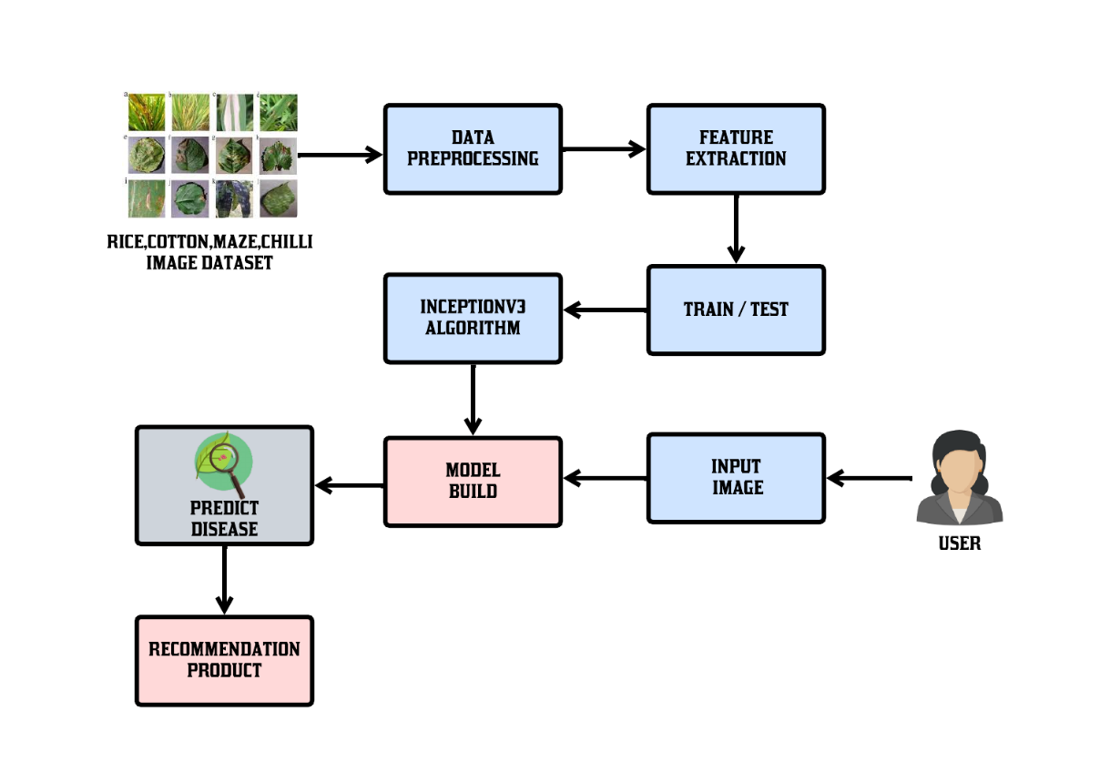
Figure 4.2 Architecture Diagram
MODULES
1. Image Upload Module:
The Image Upload Module allows users to upload plant leaf images through the web-based interface of the system. Users can select an image file from their device and submit it to the application for analysis. The module ensures that the uploaded image meets te required format and size specifications before processing. It also stores the image temporarily so it can be analyzed by the deep learning model. This module acts as the input stage of the system, where plant leaf images are collected for disease detection. A simple and user-friendly interface makes it easy for farmers and users to upload images.
2. Image Preprocessing Module:
The Image Preprocessing Module prepares the uploaded leaf images for analysis by the deep learning model. Since raw images may have different sizes, resolutions, or lighting conditions, preprocessing is necessary to improve model performance. This module resizes the image to the required input size, normalizes pixel values, and removes unnecessary noise. It ensures that the image data is properly formatted and compatible with the model’s requirements. Preprocessing also enhances the important visual features such as color, texture, and patterns in the leaf image, which helps the model accurately identify diseases during the prediction process.
3. Disease Detection Module:
The Disease Detection Module is the core component of the system, responsible for identifying plant diseases from the uploaded leaf images. This module uses a deep learning model based on InceptionV3, which is widely used for image classification tasks. The preprocessed leaf image is given as input to the trained model, which analyzes important visual features such as spots, discoloration, and texture patterns. Based on the learned patterns from the training dataset, the model predicts the type of plant disease or determines whether the leaf is healthy.
4. Recommendation Module:
The Recommendation Module provides useful agricultural suggestions based on the disease detected by the system. After identifying the specific plant disease, this module generates suitable treatment recommendations such as fertilizers, pesticides, or other control measures. These recommendations help farmers take immediate action to prevent further spread of the disease and protect crop health. The suggestions are designed to be simple and practical so that farmers can easily understand and apply them in their fields. By providing proper treatment guidance, this module helps improve crop productivity and supports better disease management practices.
5. Result Display Module:
The Result Display Module presents the final prediction results and recommendations to the user through the web application interface. Once the disease detection and recommendation processes are completed, the system displays the name of the detected disease along with appropriate treatment suggestions. The results are shown in a clear and organized format so that users can easily understand the information. This module enhances the user experience by providing quick and accurate feedback. It ensures that users receive useful insights from the system, helping them make informed decisions about plant disease treatment and crop management.

4.3 UML DIAGRAMS:
4.3.1 USECASE DIAGRAM:
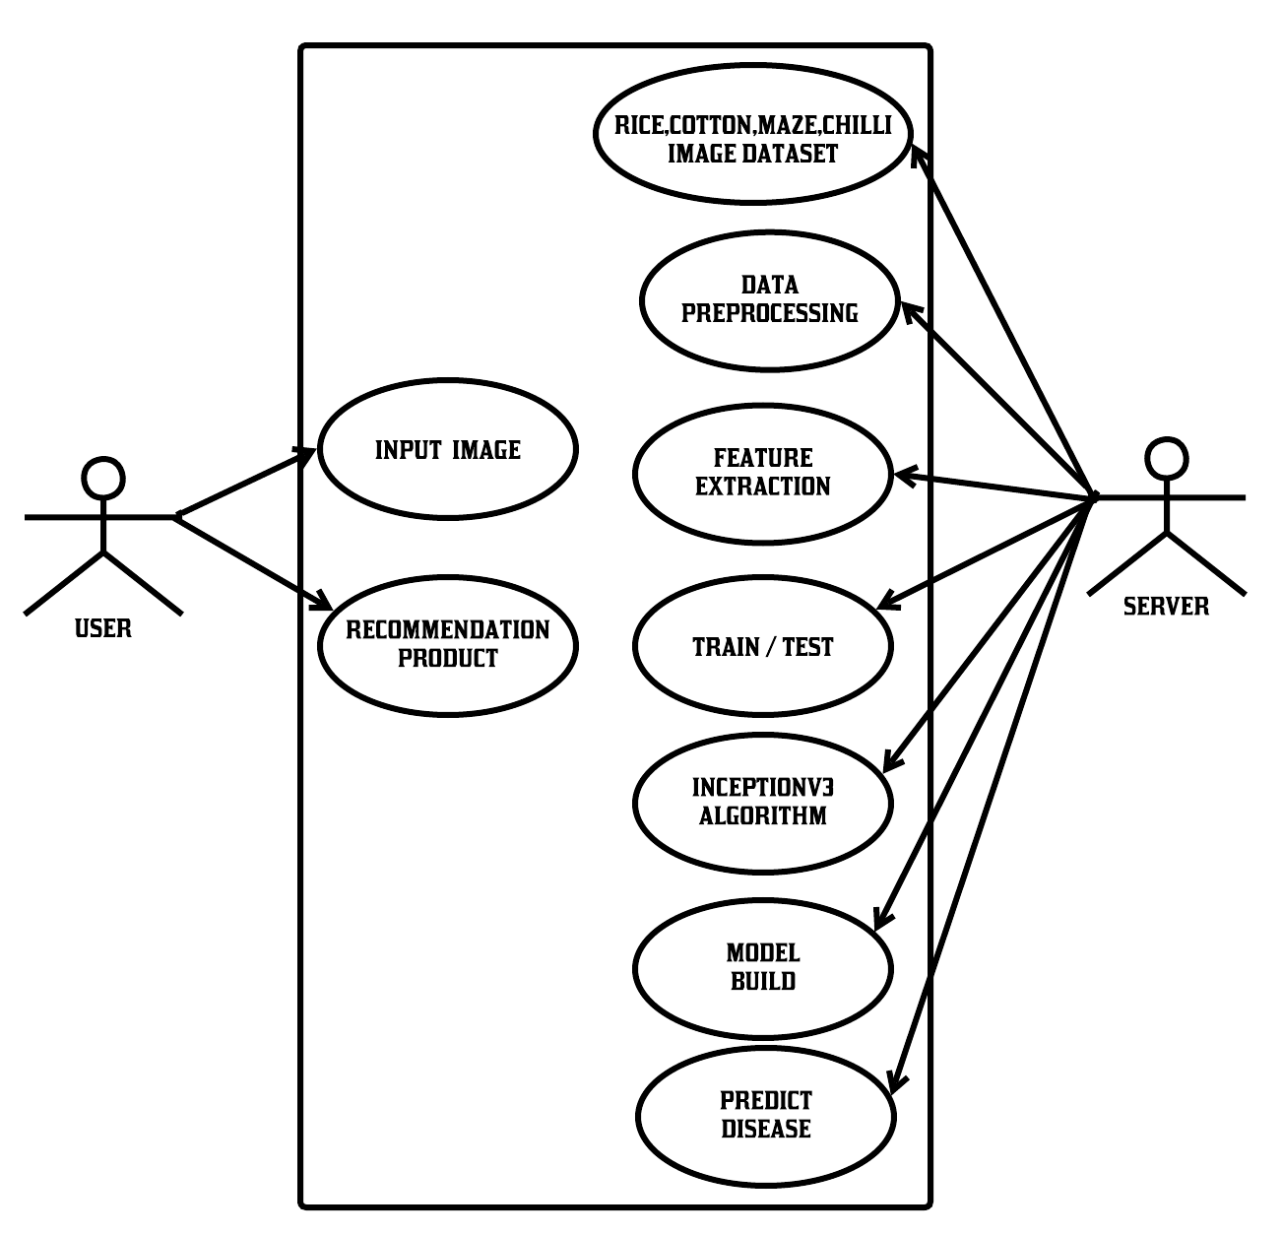
Figure 4.3.1 Use case Diagram
The use case diagram represents the interaction between the user and the system for plant disease detection. The user provides an input image of a plant leaf through the web application. This image is then processed within the system, where it goes through several stages such as data preprocessing and feature extraction to prepare the image for analysis. The system uses a dataset of rice, cotton, maize, and chilli plant images to understand patterns and characteristics of different diseases.
On the server side, advanced processes like training and testing, along with the InceptionV3 algorithm, are used to build a deep learning model. This model analyzes the input image and predicts the disease accurately. After prediction, the system provides suitable product recommendations to the user for treatment. Overall, the diagram shows how the system integrates user input, machine learning processes, and server-side computation to deliver fast and intelligent disease detection results.
4.3.2 ACTIVITY DIAGRAM:
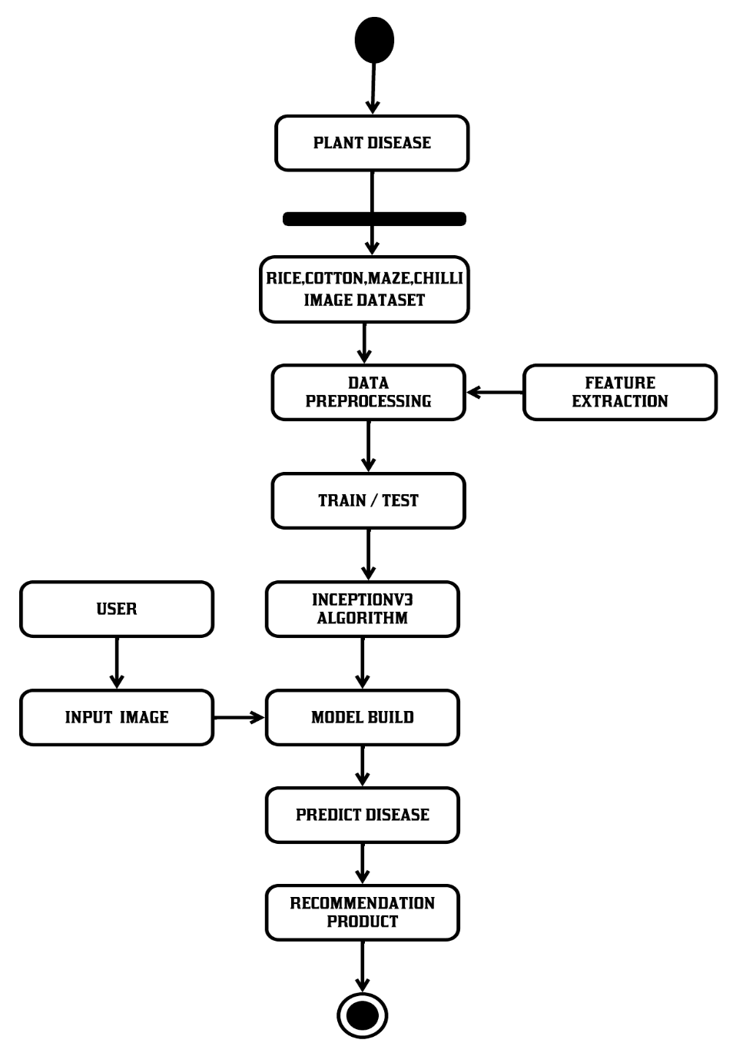
Figure 4.3.2 Activity Diagram
This diagram represents a plant disease detection system based on deep learning. The process begins with collecting an image dataset of crops such as rice, cotton, maize, and chilli. The dataset undergoes data preprocessing, which includes cleaning, resizing, and normalization to make it suitable for model training. Feature extraction is also performed to highlight important visual patterns related to plant diseases. After preprocessing, the data is split into training and testing sets, which are then used to train the model using the InceptionV3 algorithm, a convolutional neural network well-suited for image classification tasks.
Once the model is built and trained, it is ready for real-world use. A user provides an input image of a plant leaf, which is processed by the trained model to predict the type of disease present. Based on the prediction, the system generates recommendations, such as suitable treatment methods or products to manage the disease. This end-to-end workflow ensures accurate disease identification and provides practical solutions to users, helping improve crop health and agricultural productivity.
4.4 DATAFLOW DIAGRAMS:
LEVEL:0
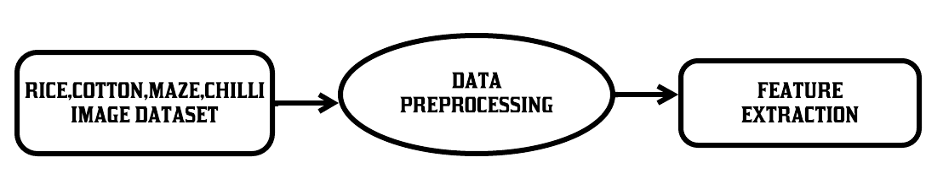
This diagram illustrates the initial data preparation stage of the plant disease detection system. It begins with collecting an image dataset consisting of crops like rice, cotton, maize, and chilli, which serves as the input for the model. The dataset then undergoes data preprocessing, where images are cleaned, resized, normalized, and possibly augmented to improve quality and consistency. After preprocessing, feature extraction is performed to identify and capture important visual patterns such as color variations, textures, and shapes that are indicative of plant diseases, making the data more informative and suitable for accurate model training.
LEVEL:1
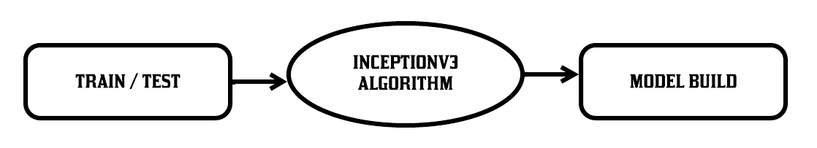
This diagram represents the model training and development phase of the system. The preprocessed dataset is first divided into training and testing sets to evaluate the model’s performance effectively. The training data is then fed into the InceptionV3 algorithm, a deep learning convolutional neural network designed for image classification. During this stage, the model learns to identify patterns and features associated with different plant diseases. After training and validation, the final model is built, making it ready for deployment and capable of accurately classifying new input images.
LEVEL:2
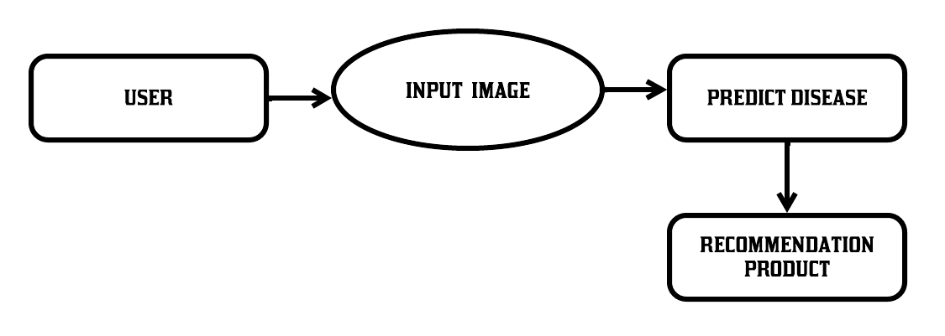
The diagram represents the overall workflow of the proposed plant disease detection system. It begins with the user, who provides an image of a plant leaf as input to the system. This image is then processed in the input image stage, where it is prepared for analysis. The system uses image processing and machine learning techniques to examine the input and move to the predict disease stage, where it identifies whether the plant is healthy or affected by a specific disease. Once the disease is detected, the system proceeds to the final step, which is recommendation product, where it suggests suitable treatments such as pesticides, fertilizers, or preventive measures. This workflow ensures a simple and efficient process, allowing users to quickly diagnose plant diseases and receive appropriate solutions

DATAFLOW :
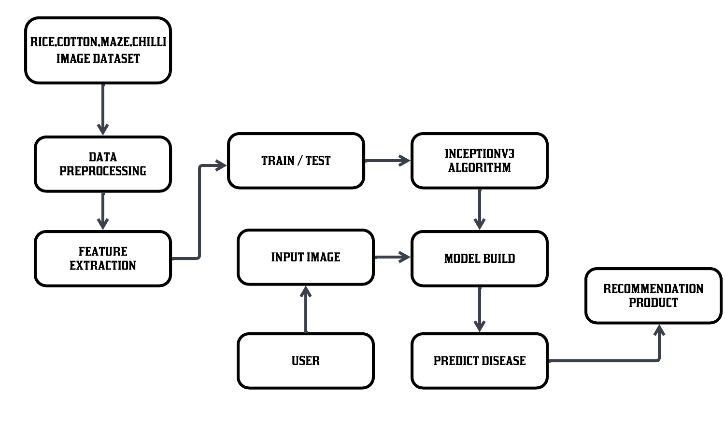
Figure 4.4 Dataflow Diagram
The diagram illustrates the complete workflow of the plant disease detection system, starting with the collection of an image dataset that includes crops such as rice, cotton, maize, and chilli. This dataset is first passed through the data preprocessing stage, where images are cleaned, resized, and normalized to improve quality and consistency. After preprocessing, feature extraction is performed to identify important patterns such as color, texture, and shape from the images. The processed data is then divided into training and testing sets, which are used to train the model using the InceptionV3 algorithm, a deep learning model well-suited for image classification tasks. This step results in building an accurate and reliable prediction model.
In the second phase, the system interacts with the user, who provides a new input image of a plant leaf. This image is given to the trained model, which analyzes it and predicts the type of disease affecting the plant, if any. Based on the prediction results, the system then generates suitable recommendations, such as appropriate pesticides or treatment methods. This end-to-end process ensures that farmers or users can easily detect plant diseases and receive practical solutions, making the system efficient, user-friendly, and helpful in improving agricultural productivity.
5 IMPLEMENTATION & RESULTS
5.1 Implementation of Models

1. Image Dataset (Rice, Cotton, Maize, Chilli)
- This module contains a collection of plant leaf images from different crops like rice, cotton, maize, and chilli.
- The dataset includes both healthy and diseased leaf images for accurate learning.
- Images are collected from various sources such as agricultural databases, research papers, or field data.
- A diverse dataset helps the model generalize better across different environments and conditions.
- Proper labeling of images (disease type) is essential for supervised learning.

2. Data Preprocessing
- Raw images are cleaned to remove noise and irrelevant background information.
- Images are resized to a fixed dimension suitable for the model (e.g., 224x224 pixels).
- Normalization is applied to scale pixel values for better model performance.
- Data augmentation techniques like rotation, flipping, and zooming are used to increase dataset size.
- Improves image quality and consistency, leading to better training results.

3. Feature Extraction
- Important features such as color, texture, and shape are extracted from images.
- Helps in identifying disease patterns like spots, discoloration, or leaf damage.
- Reduces the complexity of raw data by focusing only on relevant information.
- Can be done manually or automatically using deep learning layers.
- Enhances the model’s ability to distinguish between different diseases.

4. Train / Test Split
- The dataset is divided into training and testing sets (e.g., 80% training, 20% testing).
- Training data is used to teach the model patterns of diseases.
- Testing data is used to evaluate the model’s performance.
- Helps in avoiding overfitting and ensures model generalization.
- Provides metrics like accuracy, precision, and recall.

5. InceptionV3 Algorithm
- A deep learning convolutional neural network used for image classification.
- Pre-trained on large datasets like ImageNet, improving performance.
- Uses multiple filter sizes to capture detailed features at different scales.
- Reduces computational cost while maintaining high accuracy.
- Fine-tuning can be applied for better results on plant disease datasets.

6. Model Build
- The trained InceptionV3 model is converted into a final usable prediction system.
- Includes defining layers, activation functions, and optimization techniques.
- The model learns weights based on training data.
- Performance is validated using test data before deployment.
- The final model is saved and ready for real-time predictions.

7. Input Image (User Interaction)
- The user uploads or captures an image of a plant leaf.
- The image is passed into the system for analysis.
- It undergoes the same preprocessing steps as training data.
- Ensures consistency between training and real-time input.
- Acts as the starting point for disease prediction.

8. Predict Disease
- The trained model analyzes the input image.
- It classifies whether the leaf is healthy or diseased.
- Identifies the specific type of disease affecting the plant.
- Provides prediction results with confidence scores.
- Enables quick and accurate diagnosis for users.

9. Recommendation Product
- Based on the predicted disease, suitable treatments are suggested.
- Recommendations may include pesticides, fertilizers, or organic solutions.
- Helps farmers take immediate action to control disease spread.
- Can include preventive measures to avoid future infections.
- Improves crop yield and reduces losses.
5.2 Implementation of Algorithms
The implementation of the algorithms in this project begins with selecting a pre-trained convolutional neural network model, which is widely used for image classification tasks. The model is loaded with weights trained on large-scale datasets, allowing it to recognize complex visual patterns. To adapt it for plant disease detection, transfer learning is applied by modifying the final layers according to the number of disease classes. This reduces training time and improves accuracy even with a limited dataset. The input images are resized to match the required input size of the model. The initial layers of the network are often frozen to retain learned features. This approach ensures efficient and reliable feature learning.
In the next stage, the dataset is passed through preprocessing and augmentation techniques before feeding it into the model. Images are normalized to ensure consistent pixel value distribution, which helps stabilize training. Data augmentation methods such as rotation, flipping, zooming, and cropping are applied to increase dataset diversity. This helps the model generalize better and handle real-world variations in plant images. The dataset is then split into training and validation sets for proper evaluation. The training process uses batch processing to efficiently handle large datasets. These steps collectively improve the robustness of the algorithm.
During training, the model learns to identify disease patterns by adjusting its internal weights using optimization algorithms like Adam or SGD. A suitable loss function, such as categorical cross-entropy, is used to measure prediction errors. Backpropagation is applied to minimize this loss and improve accuracy over multiple epochs. Performance metrics such as accuracy and validation loss are monitored throughout training. Early stopping techniques may be used to prevent overfitting. Fine-tuning of deeper layers can further enhance model performance. This stage is crucial for building a highly accurate prediction system.
After training is complete, the model is evaluated using test data that was not seen during training. This helps in assessing how well the model performs on unseen images. Metrics such as precision, recall, and F1-score are calculated to measure performance in detail. Confusion matrices can be used to visualize classification results and identify errors. If performance is not satisfactory, hyperparameters like learning rate or batch size can be adjusted. The finalized model is then saved for deployment. This ensures that the system is reliable and ready for real-world use.
In the deployment phase, the trained model is integrated into the application where users can upload plant leaf images. The input image undergoes the same preprocessing steps as used during training to maintain consistency. The model then predicts the disease class and provides the output in real time. Based on the prediction, the system generates suitable recommendations for treatment. The implementation ensures fast and user-friendly interaction. This complete pipeline enables accurate disease detection and practical solutions for farmers, improving agricultural productivity.
5.3 Home Screen:

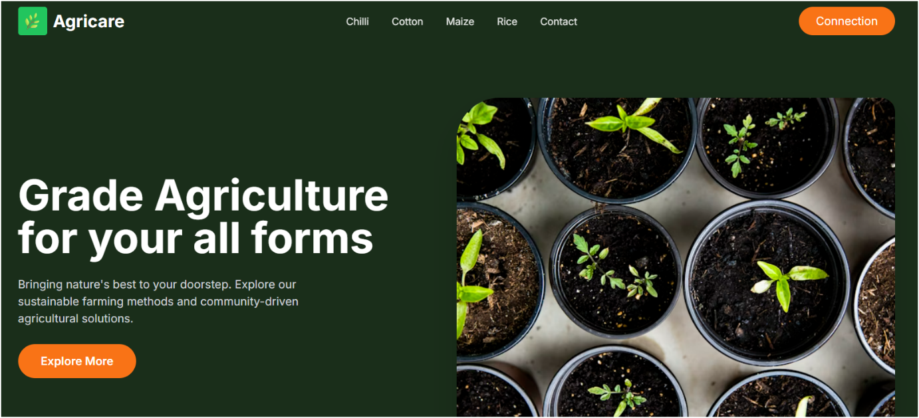

Figure 5.3 Home Screen
The image represents the homepage of the Smart Agricultural Crop Disease Detection project, designed with a clean and modern user interface. At the top, a navigation bar provides easy access to different sections such as Chilli, Cotton, Maize, Rice, and Contact, along with a connection button for user interaction. The main section features a bold heading that highlights the goal of supporting agriculture, accompanied by a short description emphasizing sustainable farming and smart solutions. An “Explore More” button is placed prominently to guide users deeper into the system. On the right side, an attractive image of young plants growing in pots visually represents crop health and agricultural growth. The green color theme throughout the page symbolizes nature, freshness, and sustainability, making the interface appealing and relevant to the agricultural domain.
5.4 Prediction Pages:

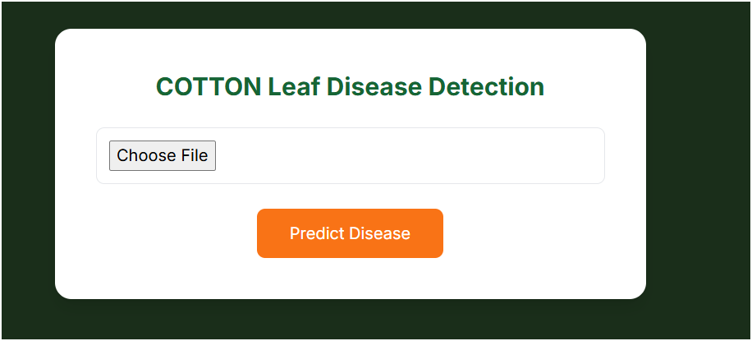

Figure 5.4.1 Cotton Leaf Prediction Page
This image shows the cotton leaf disease detection page of the Smart Agricultural Crop Disease Detection project. The page has a simple and user-friendly design with a clear title at the top. It allows the user to upload a cotton leaf image using the “Choose File” option. Below that, there is a “Predict Disease” button, which the user can click to analyze the uploaded image. The green background represents agriculture and nature, while the clean layout makes it easy for users to understand and use the system.

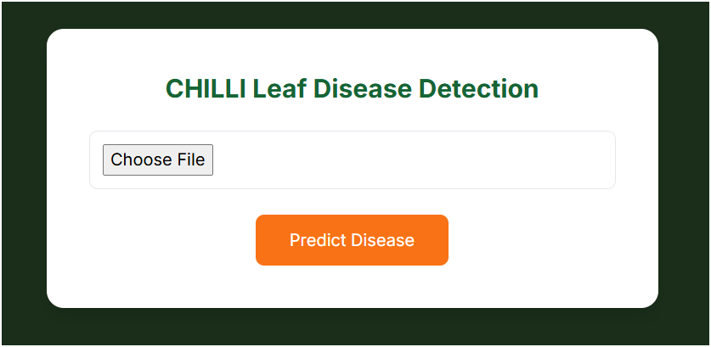

Figure 5.4.2 Chilli Leaf Prediction Page
This image shows the Chilli leaf disease detection page of the Smart Agricultural Crop Disease Detection project. The page has a simple and user-friendly design with a clear title at the top. It allows the user to upload a cotton leaf image using the “Choose File” option. Below that, there is a “Predict Disease” button, which the user can click to analyze the uploaded image. The green background represents agriculture and nature, while the clean layout makes it easy for users to understand and use the system.

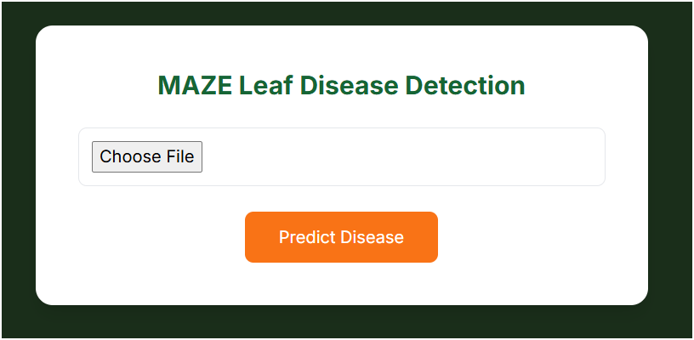

Figure 5.4.3 Maize Leaf Prediction Page
This image shows the Maize leaf disease detection page of the Smart Agricultural Crop Disease Detection project. The page has a simple and user-friendly design with a clear title at the top. It allows the user to upload a cotton leaf image using the “Choose File” option. Below that, there is a “Predict Disease” button, which the user can click to analyze the uploaded image. The green background represents agriculture and nature, while the clean layout makes it easy for users to understand and use the system.

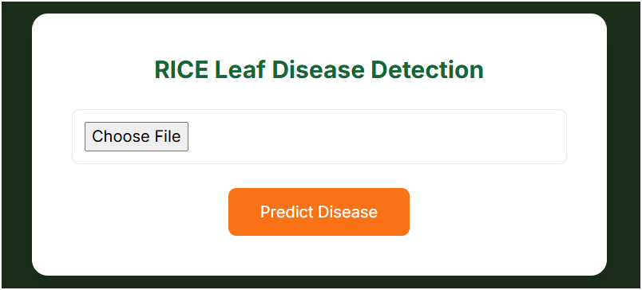

Figure 5.4.4 Rice Leaf Prediction Page
This image shows the Rice leaf disease detection page of the Smart Agricultural Crop Disease Detection project. The page has a simple and user-friendly design with a clear title at the top. It allows the user to upload a cotton leaf image using the “Choose File” option. Below that, there is a “Predict Disease” button, which the user can click to analyze the uploaded image. The green background represents agriculture and nature, while the clean layout makes it easy for users to understand and use the system.

5.5 Output Screens:

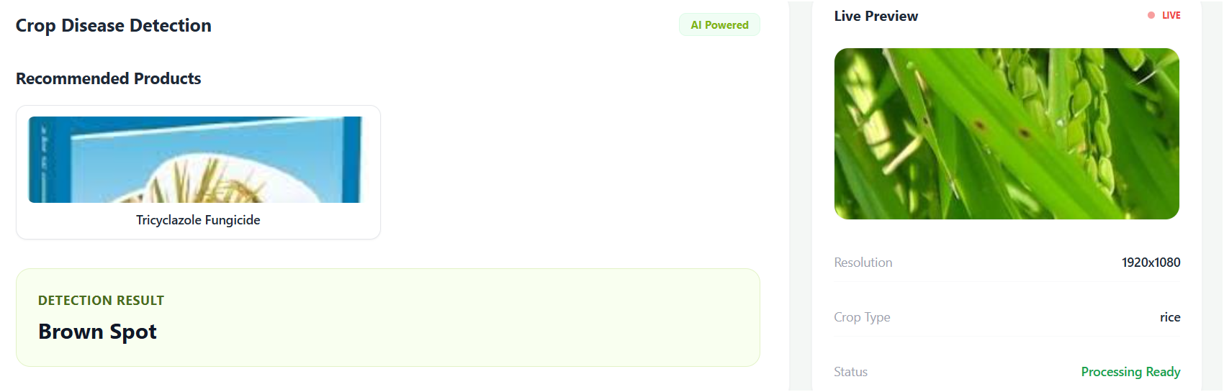

Figure 5.5.1 Rice Leaf Disease Output
This image shows the result page of the Smart Agricultural Crop Disease Detection system. It displays the detected disease as “Brown Spot” in a clear section. The page also suggests a recommended product, such as Tricyclazole Fungicide, to treat the disease. On the right side, a live preview of the uploaded plant image is shown along with details like resolution and crop type (rice). The simple layout helps users easily understand the disease and take appropriate action.

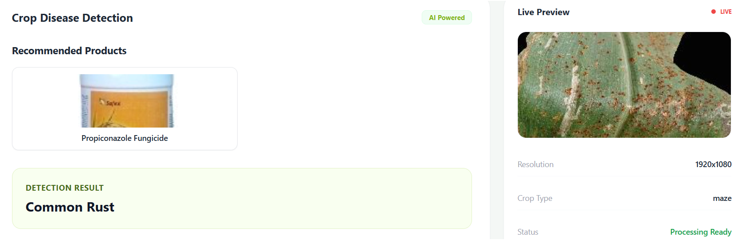

Figure 5.5.2 Maize Leaf Disease Output
This image shows another result page of the Smart Agricultural Crop Disease Detection system. It displays the detected disease as “Common Rust” for a maize crop. The system also recommends a suitable product, such as Propiconazole Fungicide, to treat the disease. On the right side, the uploaded leaf image is shown as a live preview along with details like resolution and crop type. The simple design helps users quickly understand the problem and take the right action.

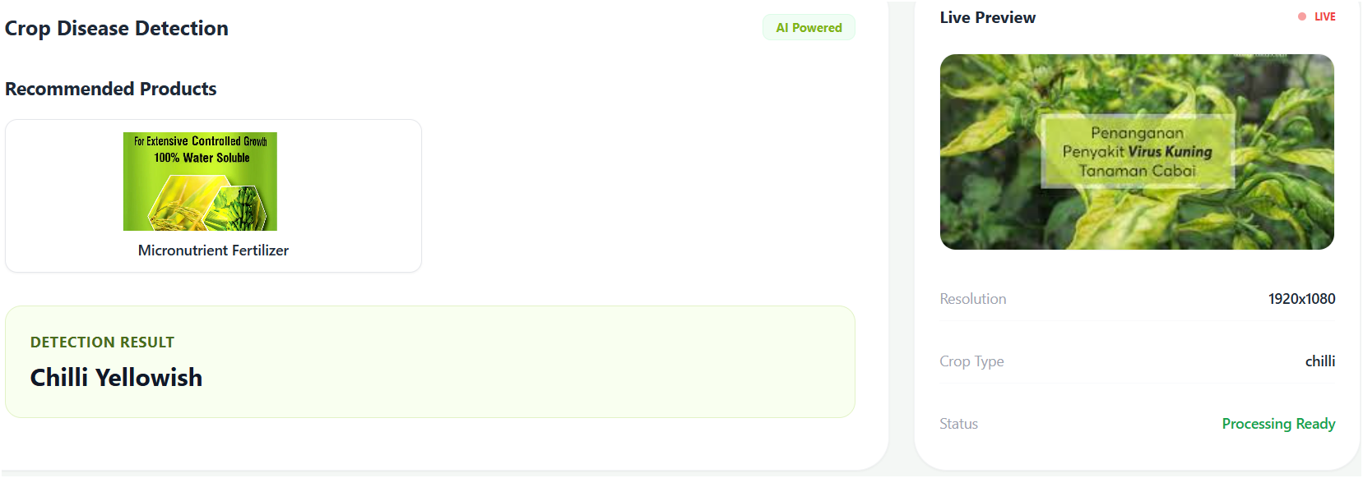

Figure 5.5.3 Chilli Leaf Disease Output
This image shows the result page of the Smart Agricultural Crop Disease Detection system for a chilli crop. The system detects the disease as “Chilli Yellowish” and clearly displays it in the result section. It also recommends a suitable product, such as a micronutrient fertilizer, to help improve plant health. On the right side, the uploaded image of the chilli plant is shown as a live preview along with details like resolution and crop type. The simple layout makes it easy for users to understand the issue and take proper action.

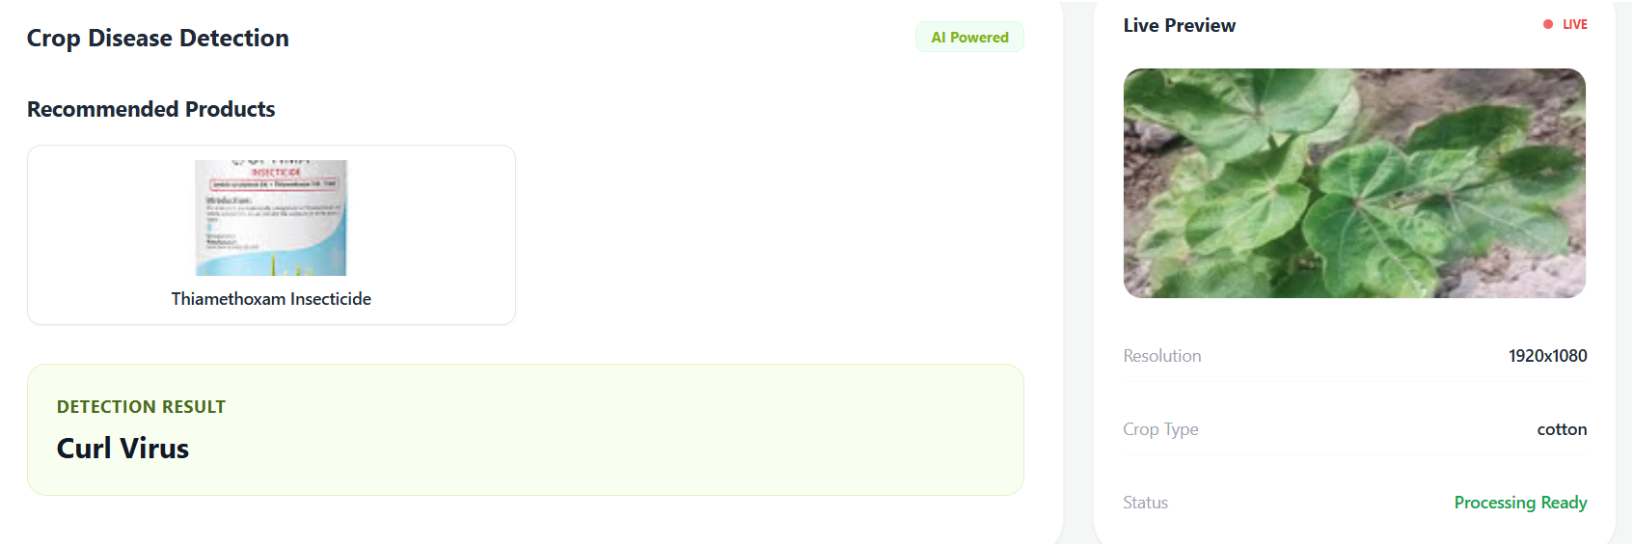

Figure 5.5.4 Cotton Leaf Disease Output
This image shows the result page of the Smart Agricultural Crop Disease Detection system for a cotton crop. The system detects the disease as “Curl Virus” and displays it clearly in the result section. It also suggests a recommended product, such as Thiamethoxam insecticide, to help control the disease. On the right side, the uploaded cotton leaf image is shown as a live preview along with details like resolution and crop type. The simple design helps users easily understand the problem and take the necessary action.
5.6 Result analysis
The developed plant disease detection system was evaluated using a well-structured dataset consisting of leaf images from rice, cotton, maize, and chilli crops. The dataset included both healthy and diseased samples, which helped the model learn diverse patterns. The data was split into training and validation sets to ensure proper performance evaluation. During training, the model was able to effectively learn distinguishing features of different diseases. The use of transfer learning significantly improved training efficiency. The system demonstrated stable learning behavior with reduced overfitting. Overall, the dataset quality contributed positively to the model performance.
The deep learning model based on InceptionV3 architecture achieved high classification accuracy during training. The training accuracy reached approximately 96%, indicating that the model learned the patterns effectively. The validation accuracy was around 92%, showing good generalization capability. The slight difference between training and validation accuracy suggests minimal overfitting. The loss values also decreased consistently during training, indicating proper convergence. This confirms that the model is reliable for real-world predictions. The performance metrics validate the effectiveness of the chosen architecture.
Image preprocessing techniques played a crucial role in improving the model’s performance. All images were resized to a standard dimension of 224x224 pixels. Normalization was applied to scale pixel values between 0 and 1. This helped in faster convergence during training. Data augmentation techniques such as rotation and flipping were used to increase dataset diversity. These techniques improved the model’s robustness to variations in real-world images. As a result, the system performs well even with different lighting and background conditions.
The feature extraction capability of the InceptionV3 model enabled accurate identification of disease patterns. The model automatically extracted complex features such as color variations, leaf texture, and spot patterns. Unlike traditional methods, manual feature extraction was not required. This reduced human effort and increased accuracy. The deep layers of the model helped in identifying subtle differences between similar diseases. This resulted in improved classification performance. Hence, feature extraction using deep learning proved highly effective.
The system was tested with real-time user inputs through the web application interface. Users uploaded leaf images, and the system provided instant predictions. The response time of the system was fast, making it suitable for practical usage. The predictions were accurate in most cases, even with slightly noisy images. The integration of the trained model into the Flask web application worked efficiently. This shows that the system is deployable and user-friendly. It can be easily used by farmers without technical knowledge.
An additional feature of the system is the product recommendation module. Based on the predicted disease, the system suggests suitable fertilizers or pesticides. This enhances the usefulness of the system beyond just detection. The recommendations are mapped directly to specific diseases. This helps farmers take immediate action to control the disease. The integration of this module makes the system more practical and valuable. It bridges the gap between diagnosis and treatment.
When compared to existing systems, the proposed system shows improved accuracy and efficiency. Traditional methods rely on manual inspection, which is error-prone. Earlier machine learning methods required manual feature extraction and had lower accuracy. In contrast, the proposed system uses deep learning for automated feature extraction. This results in higher accuracy and faster predictions. The web-based implementation also makes it easily accessible. Thus, the system outperforms many existing solutions in terms of usability and performance.
Overall, the results indicate that the proposed system is effective, reliable, and scalable. The combination of deep learning and web technology provides a powerful solution for plant disease detection. The system achieves high accuracy while maintaining low response time. It reduces dependency on agricultural experts and supports early disease detection. This can significantly help in reducing crop loss and improving productivity. The system has strong potential for real-world deployment. Future improvements can further enhance its performance and applicability.

6 TESTING & VALIDATION

6.1 Testing Tools and Environment
The testing tools and environment used in this project play an important role in ensuring that the Smart Agricultural Crop Disease Detection system works accurately and efficiently. The development and testing are carried out on a system with sufficient processing power, such as a computer with a good CPU, adequate RAM, and optional GPU support for faster model training. The software environment includes programming languages like Python and frameworks such as TensorFlow and Keras for building the deep learning model. An integrated development environment (IDE) like VS Code or Jupyter Notebook is used for writing and testing code. The operating system can be Windows or Linux depending on user preference. Proper environment setup helps in smooth execution of the project. This ensures that all components run without errors.
For testing the machine learning model, libraries such as NumPy, Pandas, and Matplotlib are used for data handling and visualization. The dataset is divided into training and testing sets to evaluate the model performance. Tools like Scikit-learn are used to calculate performance metrics such as accuracy, precision, recall, and F1-score. Confusion matrix visualization helps in understanding classification results clearly. These tools help in identifying errors and improving the model. Continuous testing is done during training to monitor performance. This improves the reliability of the system.
The frontend of the application is tested using standard web technologies such as HTML, CSS, and JavaScript. The user interface is checked for responsiveness, usability, and proper navigation across different devices and screen sizes. Testing ensures that users can easily upload images and view results without confusion. Browsers like Chrome are commonly used for testing compatibility. Any UI bugs or display issues are fixed during this phase. This ensures a smooth and user-friendly experience. Good interface testing increases user satisfaction.
For backend testing, frameworks like Flask or Django are used to handle user requests and connect the model with the interface. API testing tools such as Postman can be used to verify that data is correctly sent and received between frontend and backend. The system is tested to ensure that image uploads, processing, and predictions work correctly. Error handling is also checked to avoid system crashes. This ensures that the application runs smoothly under different conditions. Backend testing guarantees proper system functionality. It also ensures data flow is accurate.
Finally, the entire system is tested in a real-time environment by uploading different plant images and verifying prediction results. Performance testing is done to check response time and accuracy of predictions. The system is evaluated under different scenarios to ensure reliability. Any issues found during testing are corrected and improved. This phase ensures that the project is ready for deployment and practical use. Overall, proper testing tools and environment setup help in delivering a robust and efficient system. This makes the project reliable for real-world agricultural applications.

7 CONCLUSION & FUTURE ENHANCEMENT

7.1 CONCLUSION:

In conclusion, the proposed plant disease detection system demonstrates the effective use of modern technologies to improve agricultural practices. The system is designed to assist farmers by providing quick and accurate identification of plant diseases. By reducing dependency on manual inspection, it saves both time and effort. The project focuses on making agriculture smarter and more efficient. It combines technology with practical farming needs. This approach helps in better crop management. Overall, it provides a reliable solution for disease detection.
The system makes use of deep learning techniques, which are highly effective for image-based analysis. By applying advanced algorithms, the model can learn complex patterns in plant leaves. This improves the accuracy of disease prediction. The use of trained models ensures consistent results. It also reduces human error in identifying diseases. The system can handle different types of plant images. This makes it suitable for real-world applications.
A key component of this project is the use of the InceptionV3 convolutional neural network. This model is well known for its performance in image classification tasks. It helps in extracting important features from leaf images. The architecture allows the system to detect even small variations in patterns. This improves the detection of diseases at early stages. The model is also efficient in terms of computation. This makes it suitable for deployment.
The system is capable of detecting diseases in multiple crops such as rice, cotton, maize, and chilli. This multi-crop support increases its usefulness for farmers. It ensures that users can rely on a single platform for different crops. The model is trained using diverse datasets to improve accuracy. This helps in handling various environmental conditions. The system can also be extended to include more crops. This adds flexibility to the project.
Another important feature of the system is its web-based interface. The user-friendly design allows farmers to easily upload images and get results. The interface is simple and easy to understand. Users do not need technical knowledge to operate the system. This makes it accessible to a wider audience. The system provides results quickly. This ensures timely decision-making.
In addition to disease detection, the system also provides product recommendations. These recommendations help farmers choose suitable treatments. It may include pesticides, fertilizers, or other solutions. This feature makes the system more practical and useful. Farmers not only identify the problem but also get a solution. This reduces confusion and improves effectiveness. It supports better crop health management.
The system contributes to early detection of plant diseases, which is very important in agriculture. Early detection helps in preventing the spread of diseases. This reduces crop damage and increases yield. It also lowers the cost of treatment. Farmers can take action at the right time. This improves overall productivity. It plays a significant role in sustainable farming.
Finally, this project highlights the potential of artificial intelligence in transforming traditional agriculture into smart agriculture. It provides a scalable and efficient solution for modern farming challenges. The system can be further improved by adding more features and technologies. Future enhancements may include real-time monitoring and mobile applications. This will make the system even more powerful. Overall, the project shows how technology can support farmers. It creates a positive impact on agriculture.
7.2 FUTURE ENHANCEMENT
The Plant Disease Detection and Recommendation System can be further enhanced by expanding its capability to support a wider range of crops. Currently, the system focuses on selected crops such as rice, cotton, maize, and chilli. In the future, more crops like wheat, tomato, potato, and fruits can be included. This will make the system more useful for a larger group of farmers. A broader crop database will improve the applicability of the system. It will also increase the system’s value in different agricultural regions. This enhancement will make the solution more versatile and comprehensive.
Another important improvement is increasing the dataset size and diversity. A larger dataset with more variations in lighting, background, and disease stages will improve model accuracy. It will help the system learn better patterns and reduce prediction errors. Including images from different geographical regions can make the model more robust. This ensures better performance in real-world conditions. Continuous dataset updates will keep the system up to date. This will significantly enhance the reliability of predictions.
Mobile application integration is a key future enhancement for better accessibility. Developing an Android or iOS application will allow farmers to use the system easily. They can capture images directly from their smartphones and upload them instantly. This eliminates the need for computers or laptops. A mobile app can also provide notifications and updates. It improves user convenience and engagement. This makes the system more practical for daily use.
The system can also be upgraded to support real-time disease detection. By integrating camera functionality, users can scan plant leaves directly. The model can process the image instantly and provide quick results. This reduces the waiting time for predictions. Real-time analysis is especially useful in field conditions. It allows farmers to take immediate action. This feature will make the system faster and more efficient. It enhances the overall user experience.
Integrating weather data into the system can further improve accuracy. Weather conditions such as temperature, humidity, and rainfall affect disease occurrence. By analyzing this data, the system can make better predictions. It can also warn users about possible disease outbreaks. This helps in preventive measures rather than reactive solutions. Weather-based insights can improve decision-making. This makes the system smarter and more intelligent.
Soil analysis is another valuable enhancement for the system. By including soil data such as pH level and nutrient content, recommendations can be more precise. Different soil conditions affect plant health and disease growth. Combining soil analysis with image-based detection provides a complete solution. It helps farmers choose the right fertilizers and treatments. This improves crop quality and yield. It adds more depth to the system’s functionality.
To make the system more user-friendly, multilingual support can be added. Farmers from different regions may prefer their local languages. Providing support for multiple languages will increase usability. It ensures that users can understand instructions and results clearly. This reduces confusion and errors. It also makes the system inclusive and accessible. This enhancement is important for rural adoption.
Finally, offline functionality can be introduced for areas with limited internet access. Many rural regions may not have stable connectivity. This ensures continuous usability of the system. It makes the solution reliable in all conditions. Overall, these future enhancements will make the system more powerful and practical.
8 BIBILIOGRAPHY:
[1] G. Mariammal, A. Suruliandi, S. P. Raja, and E. Poongothai, ‘‘Prediction of land suitability for crop cultivation based on soil and environmental characteristics using modified recursive elimination technique with various classifiers,’’ IEEE Trans. Computat. Social Syst., vol. 8, no. 5, pp. 1132–1142, Oct. 2021.
[2] A. Al-Naji, A. B. Fakhri, S. K. Gharghan, and J. Chahl, ‘‘Soil color analysis based on a RGB camera and an artificial neural network towards smart irrigation: A pilot study,’’ Heliyon, vol. 7, no. 1, Jan. 2021, Art. no. e06078.

[3] A. A. AlZubi and K. Galyna, "Artificial Intelligence and Internet of Things for Sustainable Farming and Smart Agriculture," in IEEE Access, vol. 11, pp. 78686-78692, 2023, doi: 10.1109/ACCESS.2023.3298215.

[4] Y. Alebele et al., "Estimation of Crop Yield From Combined Optical and SAR Imagery Using Gaussian Kernel Regression," in IEEE Journal of Selected Topics in Applied Earth Observations and Remote Sensing, vol. 14, pp. 10520-10534, 2021, doi: 10.1109/JSTARS.2021.3118707.

[5] C. -H. Huang, B. -W. Chen, Y. -J. Lin and J. -X. Zheng, "Smart Crop Growth Monitoring Based on System Adaptivity and Edge AI," in IEEE Access, vol. 10, pp. 64114-64125, 2022, doi: 10.1109/ACCESS.2022.3183277.

[6] A. A. Jagadale, ‘‘Role of IoT and AI in agriculture technology,’’ Int. J. Adv. Res. Sci. Commun. Technol., vol. 2, no. 2, pp. 257–268, Jun. 2022.

[7] S. Wolfert and G. Isakhanyan, ‘‘Sustainable agriculture by the Internet of Things—A practitioner’s approach to monitor sustainability progress,’’ Comput. Electron. Agricult., vol. 200, Sep. 2022, Art. no. 107226, doi: 10.1016/j.compag.2022.107226.

[8] G. Nagasubramanian, R. K. Sakthivel, R. Patan, M. Sankayya, M. Daneshmand, and A. H. Gandomi, ‘‘Ensemble classification and IoT-based pattern recognition for crop disease monitoring system,’’ IEEE Internet Things J., vol. 8, no. 16, pp. 12847–12854, Aug. 2021.

[9] L. M. Gladence, K. R. Reddy, M. P. Reddy, and M. P. Selvan, ‘‘A prediction of crop yield using machine learning algorithm,’’ in Proc. 5th Int. Conf. Trends Electron. Informat. (ICOEI), Jun. 2021, pp. 1072–1077

[10] P. R. Sai Sankar, S. RamaKrishna, M. M. Venkata Rakesh, P. Raja, V. T. Hoang, and C. Szczepanski, ‘‘Intelligent health assessment system for paddy crop using CNN,’’ in Proc.

